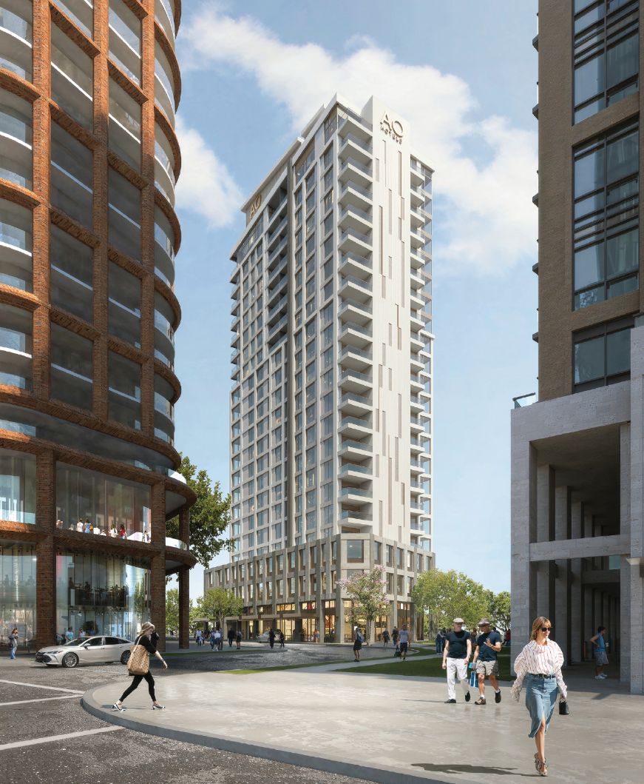
1959025 Ontario Inc. (the “Owner”) is considering the redevelopment of 2076 Old Lakeshore Road in Downtown Burlington.
This proposed development would consist of a 22-storey mixed use building with 154 hotel suites, 46 residential units, and an extension of the waterfront trail.
If the Owner chooses to pursue this redevelopment, amendments to the City of Burlington Official Plan and Zoning By-law would be required. The current Official Plan designation of the site is Downtown Mixed Use Centre, Old Lakeshore Road Mixed Use Precinct, and the current zoning is Downtown Old Lakeshore Road Zone “DL-C”.
No development applications have been submitted to the City of Burlington at this time, and the City has not made any decisions on this proposal.
A Pre-Application Community meeting has been scheduled to discuss this potential redevelopment, so that public can provide feedback to the Owner at this early stage.

The Pre-Application Community Meeting will take place:
Date: | July 15th, 2025
Start Time: | 6:30 p.m. - 8:00 p.m.
Participate On-Line via Zoom: | https://us06web.zoom.us/j/86179810605  (internet connection required – Zoom user guide available at www.burlington.ca/2076oldlakeshore)
Webinar ID: | 861 7981 0605
Participate by Telephone (audio only): | 1-647-374-4685  1 647 558 0588

During the meeting, City Planning staff will provide an overview of the development application review process. The Owner will provide an overview of planning polices in effect on the site and their development concept. There will be a question and answer session to share your thoughts on the proposal with the Owner.

Councillor Kearns and the Mayor have been invited and may also be in attendance to hear your input. Residents can subscribe to this proposed development’s webpage at Burlington.ca/developmentprojects to receive any updates about this proposal.

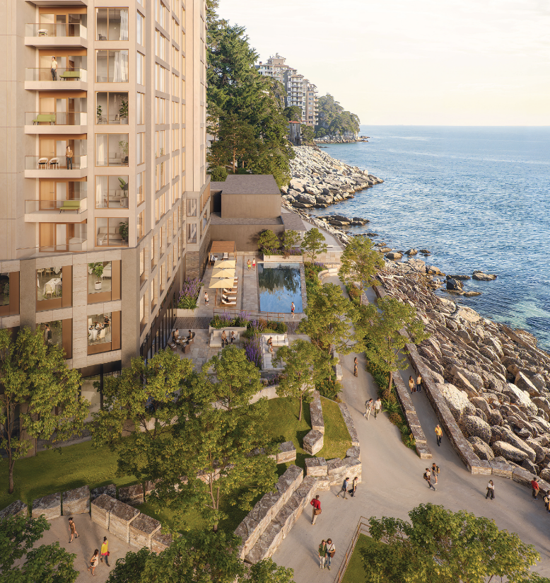
Agenda:
- Meeting to commence at 6:30 pm with opening remarks;
- City Planning staff to provide a summary of the planning process, opportunities for public consultation, and next steps;
- The project team will provide an overview of the development concept;
- Audience consultation – opportunity for questions, answers and comments; and
- Meeting adjournment.

Comments and questions for the Owner can be sent to the following:
Cale Vanderveen, MCIP, RPP, Bousfields Inc.
Planning Consultant
cvanderveen@bousfields.ca
416-947-9744 x218

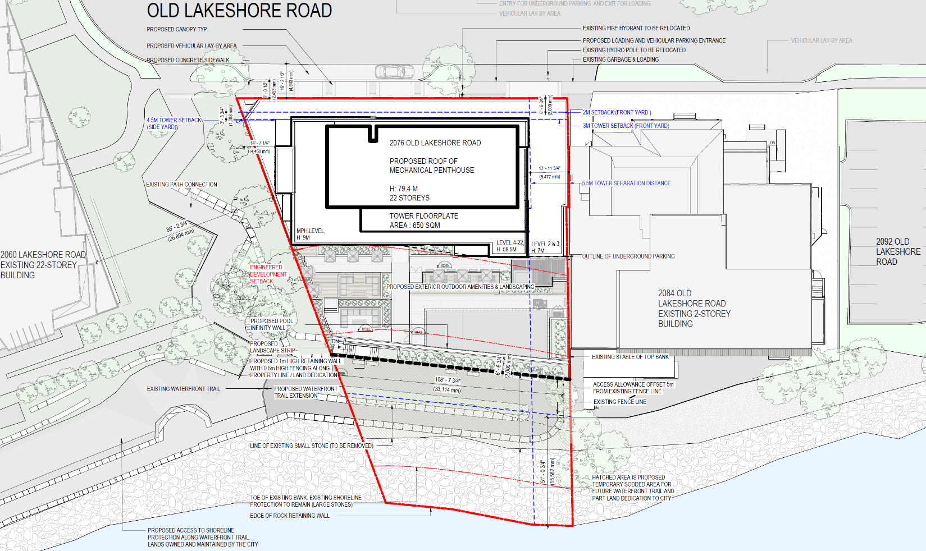

After the application has been submitted to the City, notice will be sent to residents within 120 metres of 2076 Old Lakeshore Road and details of the application will be publicly available online at Burlington.ca/developmentprojects. At this stage residents can provide comments and questions to City Staff.
Subject Site
Lake Ontario
Waterfront Trail
Old Lakeshore Road

