Environmental Assessment for Lower Rambo Creek Flood Mitigation Upstream of Caroline Street to Downstream of Martha Street - Notice of Public Information Centre

BACKGROUND
To address the potential flooding from Lower Rambo Creek, upgrades to infrastructure within the creek are needed to reduce the existing flood hazard. The focus of this project is to identify potential infrastructure improvements to help reduce flood hazard risks, build climate change resiliency, and support growth and development in the downtown area.
The project has four main hydraulic structures of interest within Lower Rambo Creek that will be investigated for potential improvements: (1) Caroline Street Enclosure, extending from Caroline Street to Maria Street, (2) Maria Street enclosure, extending from Maria Street to James Street, (3) Martha Street Culvert, and (4) Waterfront Trail (Centennial Trail) culvert.
The alternatives assessed for this project have included conveyance improvements, infrastructure improvements, temporary storage of flood flows, and flood protection. The study is building on the modelling completed for the floodplain mapping of Lower Rambo Creek recently approved by Conservation Halton.
PUBLIC ENGAGEMENT
As public engagement is an important part of the city projects, the City will be holding a Public Open House/Public Information Centre (PIC) where the potential design alternatives and final design evaluation criteria will be discussed. Public input, concerns and comments are welcomed and will be considered in the completion of the project.

When: Tuesday, May 27, 2025, 6 to 8 p.m.
Where: Centennial Hall – Burlington Public Library, Central Branch, 2331 New St., Burlington, ON

For those who are unable to attend in-person, presentation slides will be available for review on the City’s webpage. We encourage you to participate by reviewing the information materials and providing any comments to the Project Team. Information will be collected in accordance with the Municipal Freedom of Information and Protection of Privacy Act. With the exception of personal information, all comments will be become part of the public record.

If you would like more information or have any questions or comments, please contact:

Umar Malik, M. Eng., P. Eng.  City of Burlington, Stormwater Engineer - Development  426 Brant Street, P.O. Box 5013  Burlington, ON L7R 3Z6  905-335-7600, ext. 7426  Umar.Malik@burlington.ca | Robert Amos, MASc., P.Eng.  Aquafor Beech Limited.  2600 Skymark Ave. Building 6, Unit 2  Mississauga, ON L4W 5B2  416-705-2367  Amos.R@Aquaforbeech.com

Please contact the Stormwater Engineer - Development regarding disability accommodation requirements.

Study Area:
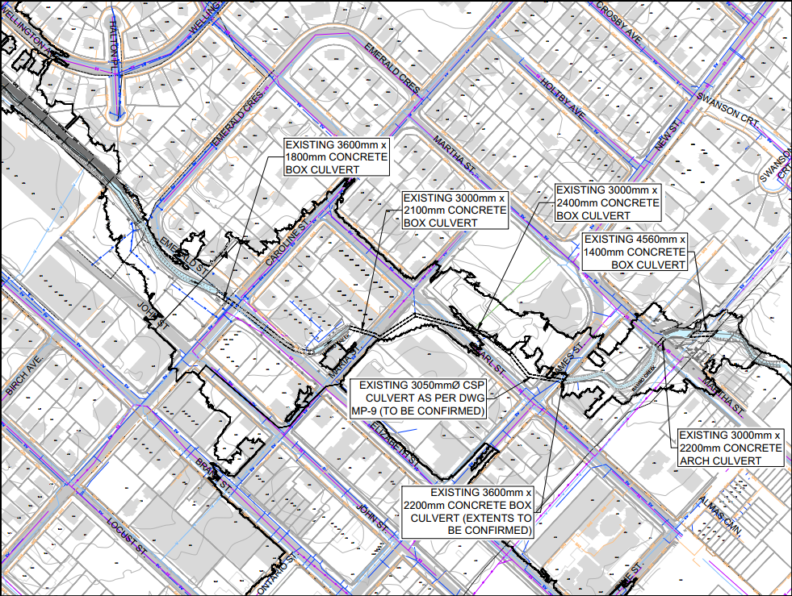

This notice was first issued on May 16, 2025.

