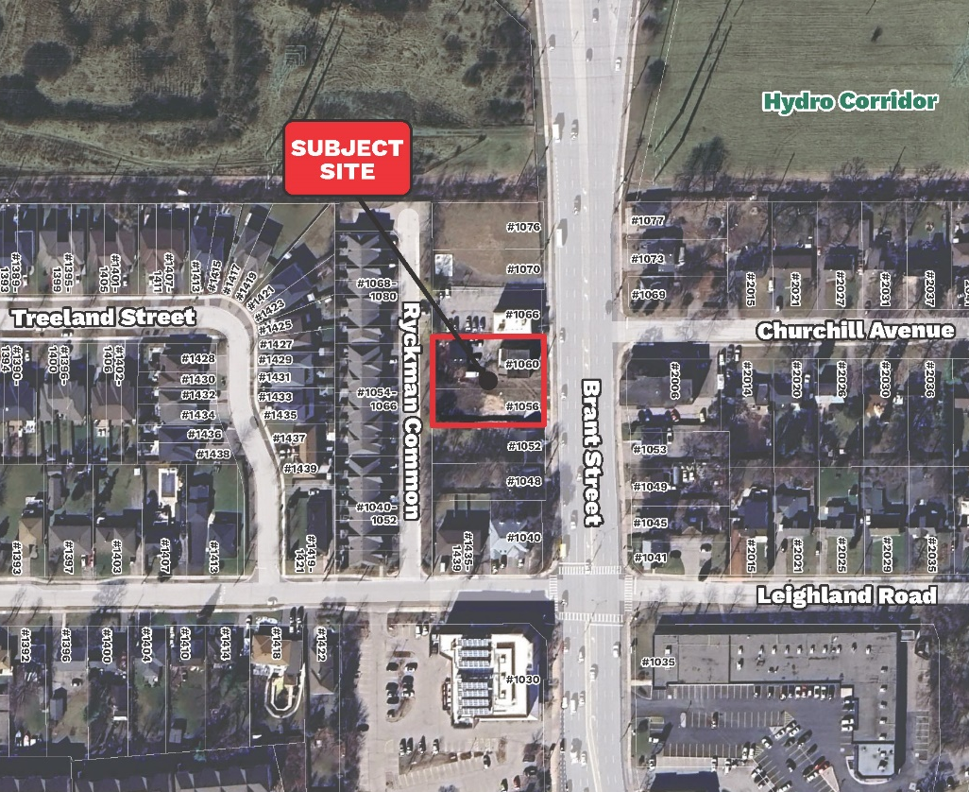
2735842, 2060188, 2735841, and 2059977 Ontario Inc. (collectively, the “owner”) is considering the redevelopment of 1056 – 1060 Brant Street.
This proposed development would consist of an 11 - storey residential building with approximately 93 residential units, including a mix of 1, 2 and 3 bedroom units.
If the owner chooses to pursue this redevelopment, it will require an amendment to the City of Burlington Official Plan and Zoning By-law. The current Official Plan designation of the site is Mixed Use Corridor – General and the current zoning is Mixed Use Corridor General Zone “MXG”.
No development applications have been submitted to the City of Burlington at this time, and the City has not made any decisions on this proposal.
A pre-application community meeting has been scheduled to discuss this potential redevelopment so that public can provide feedback to the owner at this early stage. The meeting will be held in a Hybrid format, with both in-person and virtual attendance options available.
The Pre-Application Community Meeting will take place:
Date: | May 6th, 2025
Start Time: | 6:30 p.m. - 8:30 p.m.
Location: | Burlington Art Gallery – Shoreline Room  1333 Lakeshore Rd., Burlington, ON L7S 1A9
Participate On-Line via Zoom: | https://us06web.zoom.us/j/83609899689  (internet connection required – Zoom user guide available at www.burlington.ca/1056Brant)
Webinar ID: | 836 0989 9689
Participate by Telephone (audio only): | 1 647 374 4685  1 647 558 058

During the meeting, City Planning staff will provide an overview of the development application review process. The owner will provide an overview of planning polices in effect on the site and their development concept. There will be a question and answer session to share your thoughts on the proposal with the owner.

Councillor Kearns and the Mayor have been invited and may also be in attendance to hear your input. Residents can subscribe to this proposed development’s webpage at Burlington.ca/developmentprojects to receive any updates about this proposal.

Agenda:
- Meeting to commence at 6:30 pm with opening remarks
- City Planning staff to provide a summary of the planning process, opportunities for public consultation, and next steps
- Overview of the development concept from the project consultant team
- Audience consultation – opportunity for questions, answers and comments
- Overview of next steps
- Meeting adjournment

Comments and questions for the owner can be sent to the following:
Cale Vanderveen, MCIP, RPP, Bousfields Inc.
Planning Consultant
cvanderveen@bousfields.ca
416-947-9744 x218

After the application has been submitted to the City, notice will be sent to residents within 120 metres of the site, and details of the application will be publicly available at Burlington.ca/developmentprojects. At this stage residents can provide comments and questions to City Staff.

